NORTH-EASTERN MARYLAND OFFICIALS ASSOCIATION, INC.
OFFICIALS APPLICATION
P.O. BOX 25, BEL AIR, MARYLAND, 21014
CIRCLE BELOW SPORTS DESIRED TO OFFICIATE
E-MAIL APPLICATION TO VP(SPORT)) & TO TREASURER
TREASURER CHUCK GREEN chuck.green38@yahoo.com VP FOOTBALL MIKE WEST coachmikewest@verizon.net
VP VOLLEYBALL FRANK NOVAK franknovak3rd@gmail.com VP SWIMMING KEVIN WALLS__csmmet@aol.com
VP BASEBALL DAN PIERCE dannypierce@comcast.net VP SOFTBALL RICK MORRIS wvmdmorris@gmail.com
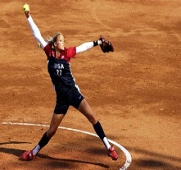
NAME:________________________________________________________
ADDRESS:______________________________________________________
ADDRESS:_CITY________________STATE___ZIP _______________________
TELEPHONE #’S: CELL:____________________________________________ _ WORK:________________________HOME:___________________________
E-MAIL ADDRESS(MUST HAVE FOR ASSIGNING):
______________________________________________________________
SOCIAL SECURITY#___ _______-__________-_________________________
OFFICIATING EXPERIENCE/ REFERENCES:_____________________________
_______________________________________________________________________________________________________________________________________________________________________________________________________________________________________________________________________________________________________________________________________________

